Individual Project Report 2

Week 2:

This week I refined the mechanics a little more so that they are more fluid. The character’s transition to the ceiling is a lot smoother and is more like how I want it to be. I want my game to “seem” confusing, but be simple in retrospect. I’ve got two puzzles down, and I have created a script that allows for visible objects to appear once the player has walked through them and is currently not looking at them.

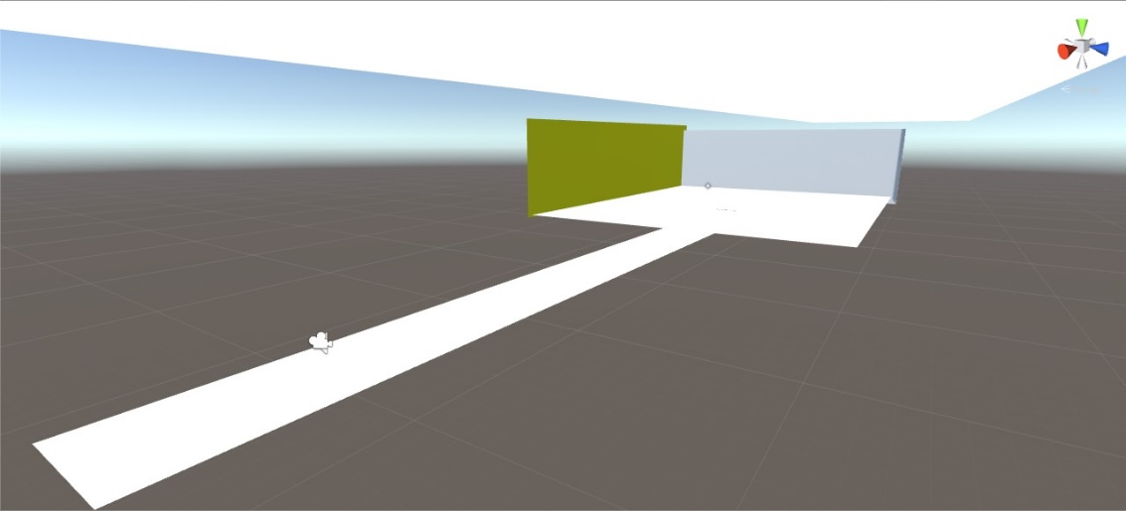Next week I’m hoping to add more puzzles and refine the mechanics even more. One problem I’m having is with color. My game is mostly made with Planes so that the environment looks more confusing than it is. The only problem with that, is that the environment also looks really bland and boring. I’m trying to think about how I could maybe use textures or even lighting to make it seem more interesting.

